2026 State Transportation Improvement Program (STIP) Fact Sheet
Executive Summary
Based on current projects advancing in the Kern COG 2026 Regional Transportation Improvement Program (2026 RTIP), this Kern COG 2026 RTIP submittal will accomplish the following:

Conform to air quality budgets presented by EPA / ARB;

Improve public safety on highways of regional and national significance; and

Improve economic benefits to the region, the state and as a national freight corridor.

The 2026 fund cycle reflects $56,891,000 of programmed Regional Improvement Program (RIP) for prior year and fiscal years 2026-2027 through 2030-31. The total amount of RIP funding includes $26,371,000 of new RIP programming. The projects selected for funding are identified in the currently approved Kern COG’s 2022 Regional Transportation Plan (RTP) and found to be consistent with the goals and investment strategies of the RTP.

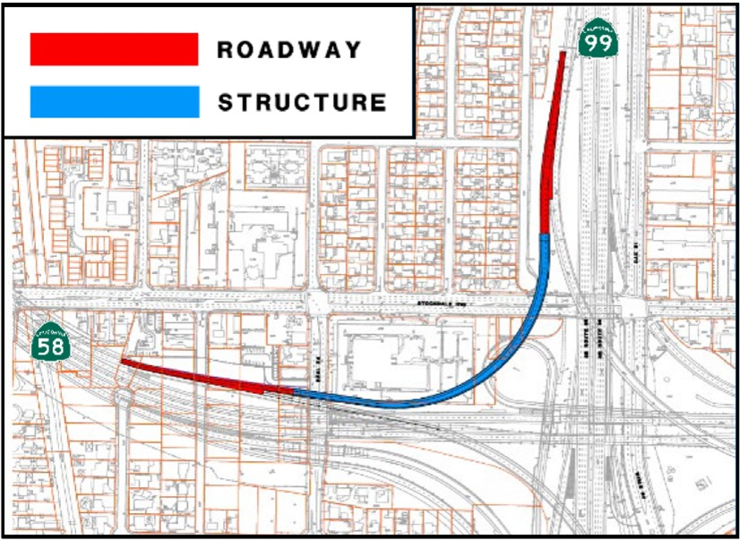
SR 58/99 Phase 2 Connector
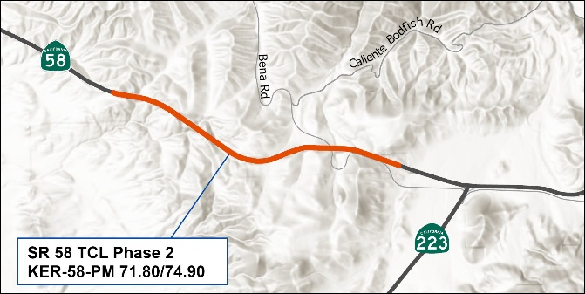
SR 58 Truck Climbing Lane Phase 2

Benefits
The Kern COG 2026 RTIP projects deliver regional, statewide, and national benefits. The SR 58/SR 99 Connector and SR 58 Truck Climbing Lane Phase 2 improve safety by reducing injury collisions, enhance traffic flow to cut congestion, support the environment through lower emissions, advance equity by removing truck traffic from disadvantaged communities, and strengthen the economy by facilitating efficient goods movement along nationally significant freight corridors.

Goals and Objectives
The Kern COG 2026 RTIP advances the goals and objectives of the 2022 RTP/SCS by funding regionally significant, financially constrained projects that improve safety, mobility, and air quality. The Centennial Corridor Phase 2 Connector closes a critical freeway gap at SR 58/SR 99, enhancing capacity, improving travel reliability, and reducing emissions. The SR 58 Truck Climbing Lane strengthens goods movement along a vital freight corridor, supporting economic vitality and system resilience. Together, these projects advance RTP/SCS objectives for greenhouse gas reduction, equitable access, and multimodal connectivity. In addition, the RTIP supports the Caltrans State Route 99 Comprehensive Multimodal Corridor Plan (CMCP) by addressing anticipated increases in freight traffic associated with new distribution centers and manufacturing facilities in Kern County. These improvements improve truck time reliability and goods movement efficiency, consistent with CMCP strategies. RTIP also supports the Active Transportation Plan, by reducing the impact to bike lanes and improving pedestrian safety by removing truck traffic from local arterials. These projects demonstrate Kern COG’s commitment to advancing multimodal mobility, economic competitiveness, and sustainable community development across the region.
The proposed projects in the 2026 RTIP contribute to one or more goals in the Climate Action Plan for Transportation infrastructure (CAPTI), Caltrans’ Race and Equity Action Plan (REAP), California’s Freight Mobility Plan (CFMP), and the State Route 99 Comprehensive Multimodal Corridor Plan (CMCP) by enhancing climate resilience, equity and freight efficiency, mobility, and safety. These projects deliver measurable benefits to local and regional communities.

